Neon Dungeon

- Overview
- Gameplay
- Dungeon Algorithm
- AI Algorithm

Overview

This is a procedural dungeon generator game where the dungeon layout will change each and every time you play the game. The goal of the game is to collect 10 neon relics and survive bro neon balls that try to kill you. You have 3 lives if you lose them the game is over. The player can shoot the neon balls to survive. The neon balls find their path inside the dungeon to come to the player to kill.

Gameplay

This is a top-down shooter and the player movement is using keyboard, with the mouse you can turn around to shoot and rotate the player so that you can kill the neon balls. The blue neon relics are the objects you have to collect and it will be scattered around the dungeon. Whenever the dungeon generates procedurally the relics find places to spawn across the dungeon layout so that the player goes around the whole dungeon to collect them. The player should keep an eye on the green circles which is the health bar, if the three circles disappear the player dies.

Dungeon Algorithm

The dungeon uses an algorithm called Binary Space Partitioning where the user give min and max value of space and we divide the space using vertical and horizontal line in a random point by taking care of the minimum room size and add them to a tree structure. After adding we need to check the rooms can be divided much further, if it’s possible we have to divide and add it to the tree structure. We need to stop adding it when the rooms cannot be divided much further. For every room created find random corner points and create a mesh to add the floor for the dungeon. Starting from the youngest tree branch that is the last room created we need to add corridors by connecting the youngest to the previous room and vice versa. Repeat this process until you reach the top eldest branch.

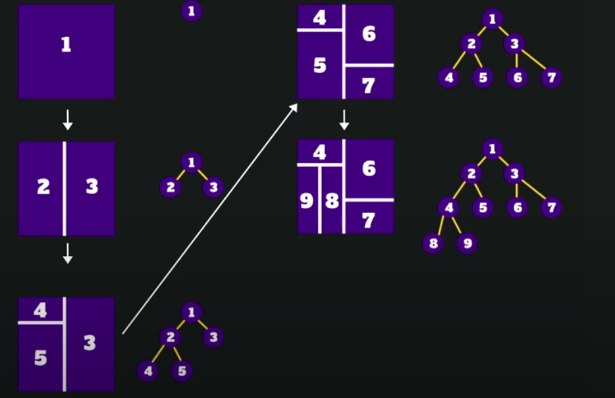

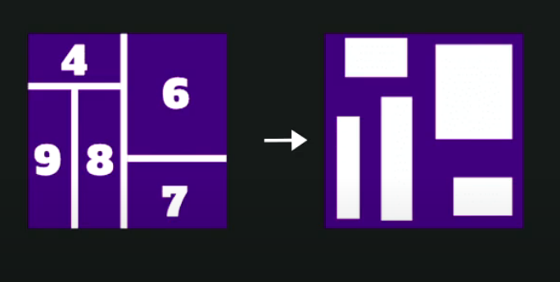

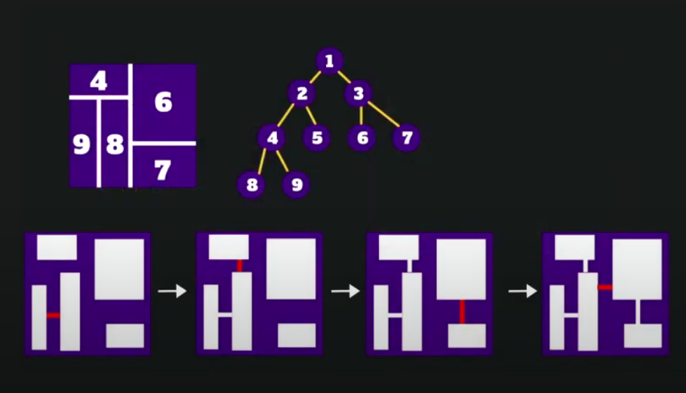

AI Algorithm

The AI in this game uses a component called nav mesh. Nav mesh is a designated mesh in Unity, which indicates walkable or non-walkable areas in the scene. The nav mesh incorporates pathfinding and AI controlled navigation. The nav mesh agent component is the brain for the Game Object to move around the scene and nav mesh surface is the component that lays down the designated mesh the agent can walk or jump on.

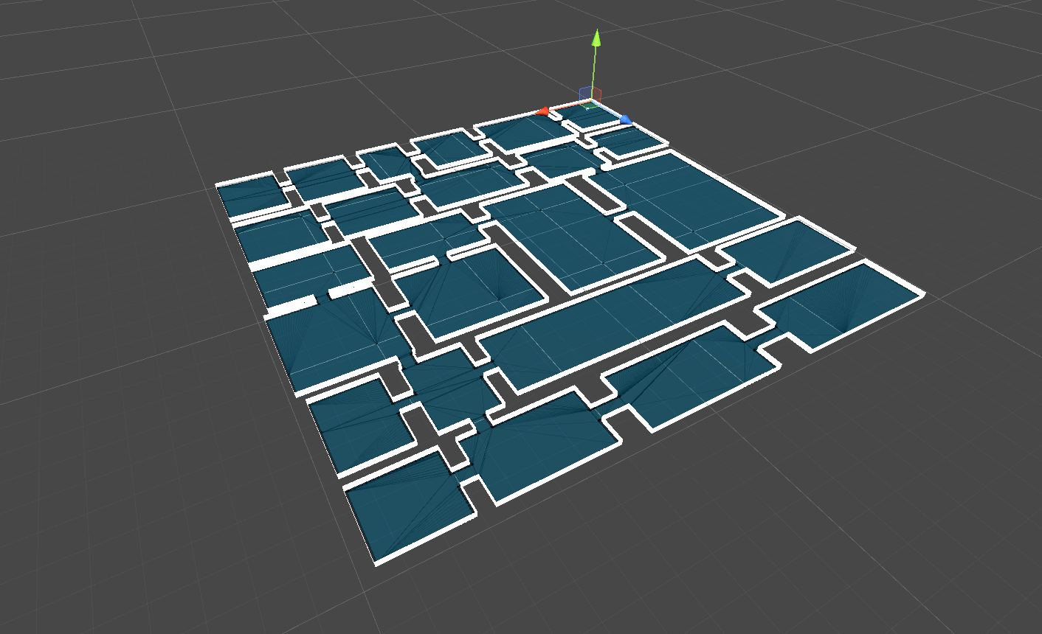

The blue area in this image is the nav mesh that is applied by the nav mesh surface component for the nav mesh agent. This dungeon game generated this nav mesh in run time and spawn the AIs in runtime and makes them find the path to the player to damage it.

